Online Bulletin Board User Guide

(Employee)

To access the system type or copy this url in the web browser: <url here>

1. **Login**

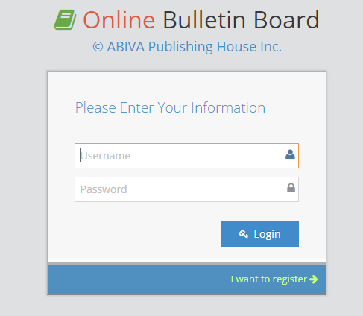

If you have provided the correct username and password, you will be redirected to the index page of the system. Otherwise you will be prompted with this dialog box:

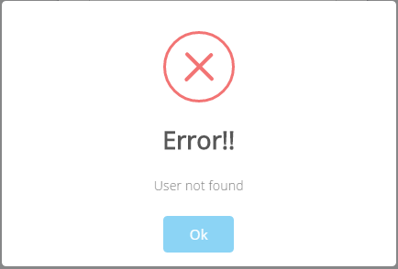

1. **Index Page and Menu**

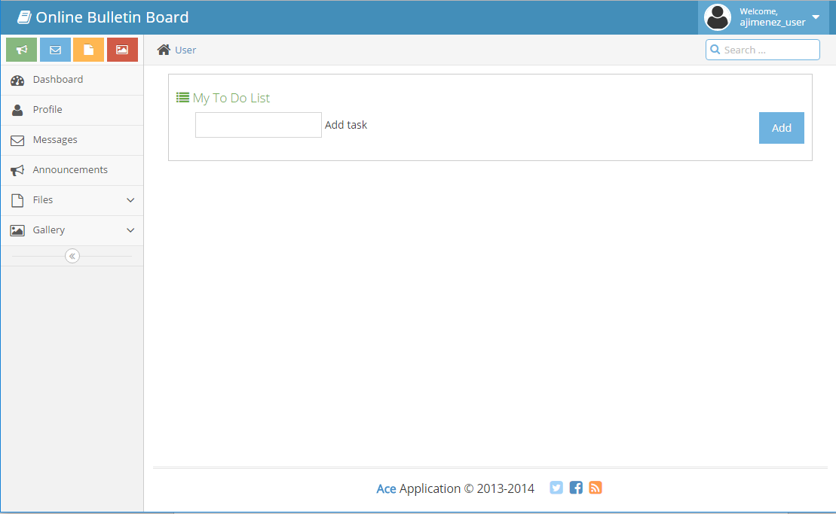

This is the index page in which the user will be redirected after logging in. You can also see the side menu which will help you in navigating the system.

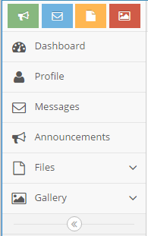

The index page provides a to do list. To use this, input any text in the Add Task field then click the Add button.

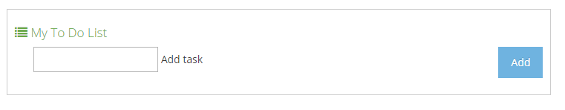

The task you’ve entered will be enumerated in a list.

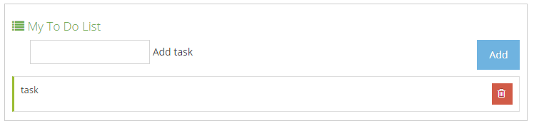

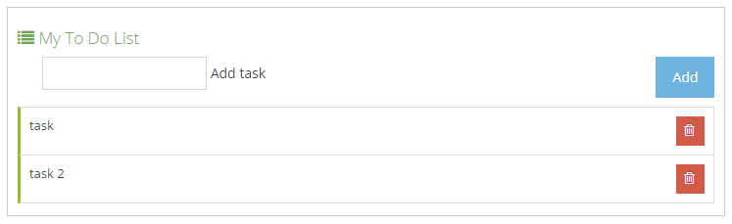

To mark a task as finished, click its row once. Click it again to remove the mark.

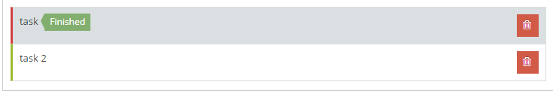

Click the button to delete a task.

1. **Profile**

Click the button

You will be redirected to the User Profile Page. You can see the details you have registered.

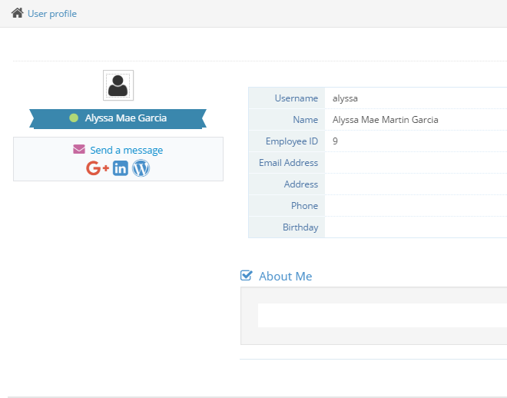

You are able to fill out the blank fields in the form by clicking the button found at the upper right corner of your screen.

After clicking the Edit Profile button, you will are now able to fill out and provide additional details to your profile.

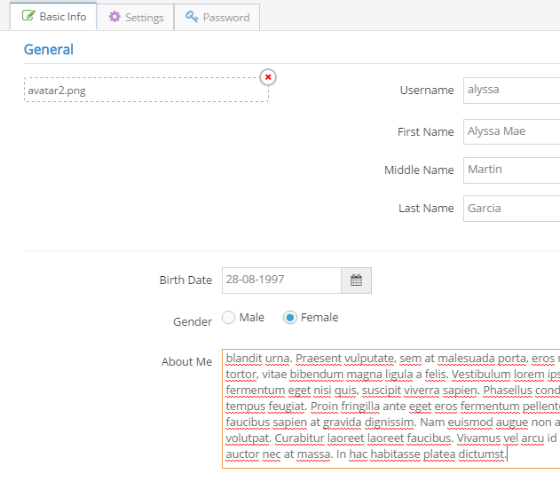

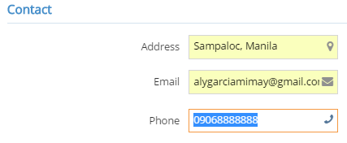

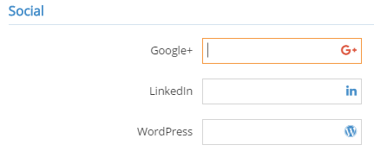

To change your profile picture, click this:

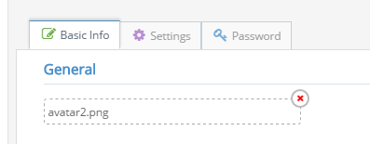

The file chooser will show, then choose your profile picture.

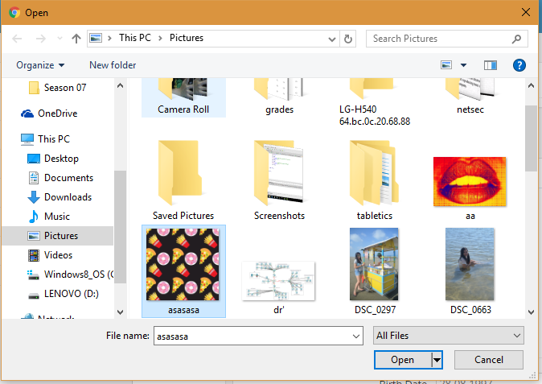

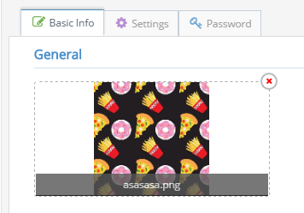

Click the  button at the bottom part of the form to save your information.

After saving, you can now see you updated user profile.

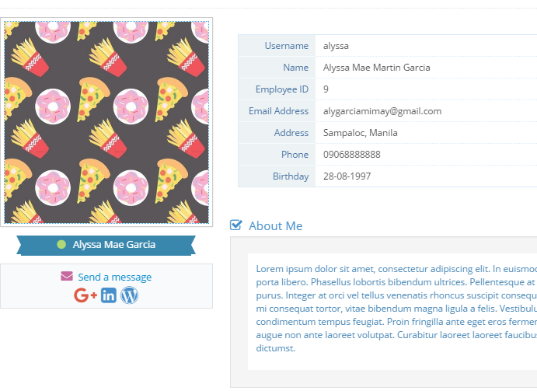

1. **Change Password**

Click  then click the Password tab that can be seen at the top panel of the form.



This will then show this form:

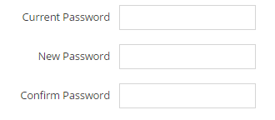

To change password, enter your current password then enter your new password. If you have successfully changed your password, you will see this:

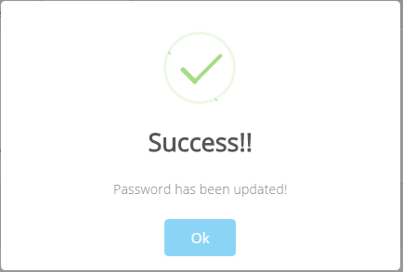

Otherwise, you will be prompted with this:

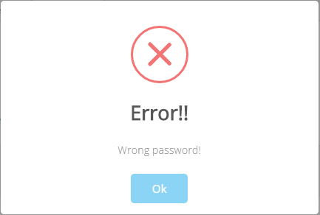

Your old password cannot be the same as your new password.

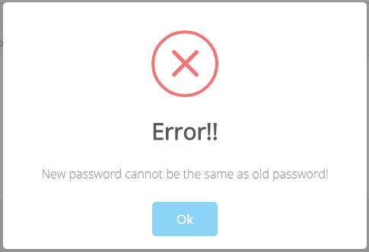

1. **Gallery**

Click the Gallery tab from the side menu then click Upload pictures.

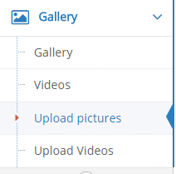

The system will redirect you to the uploading page.

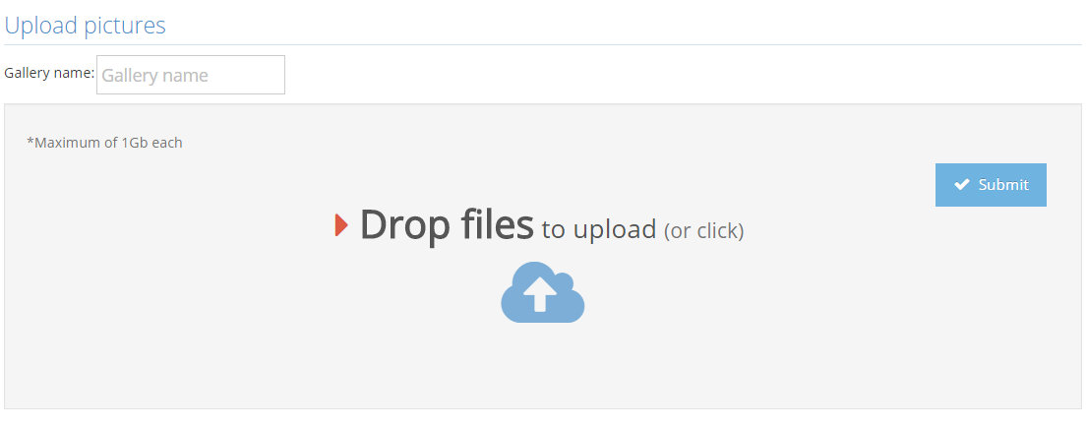

Provide a gallery name

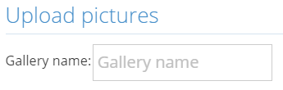

And then click the dropzone area, this will show the file chooser. Drag and drop files to the area, or simply click the files. Only files with .jpg,.jpeg,.png and .gif extensions are accepted with the max size of 1Gb each picture.



Click the  button. The speed of the uploading of pictures depends on the file size and the number of pictures being uploaded simultaneously.

You will then be redirected to the album you have created.

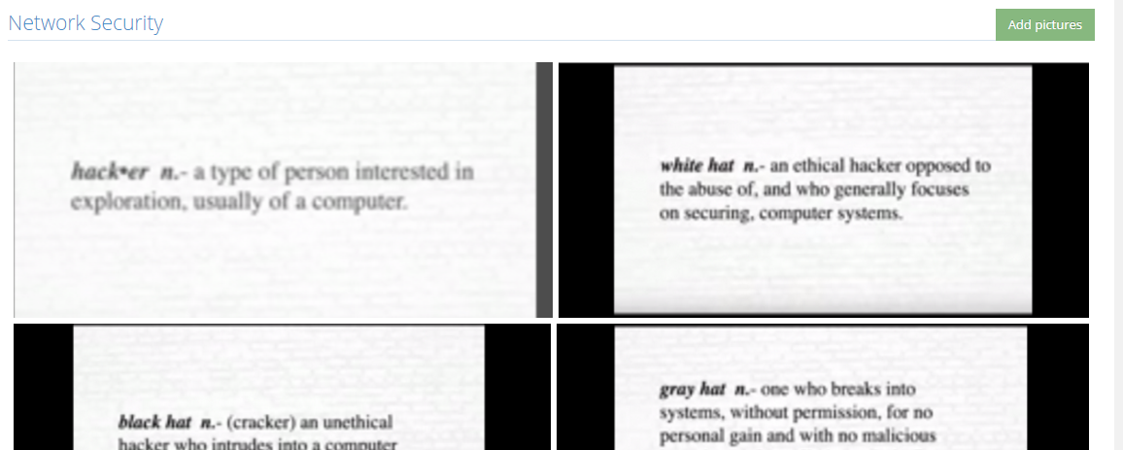

Click a picture to view

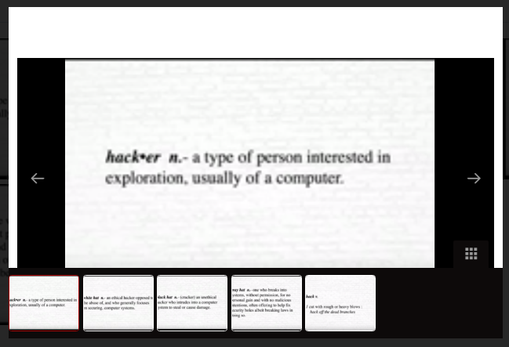

To add more pictures in the gallery, click thebutton

Click Manage Files to delete your pictures. You can delete only those you have uploaded.

To upload videos, click Upload videos.



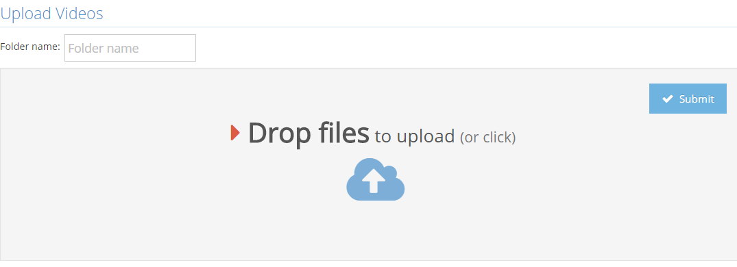

Upload videos by clicking the dropzone and then select the videos to be uploaded. Any video file is accepted with the max size of 1Gb each video.

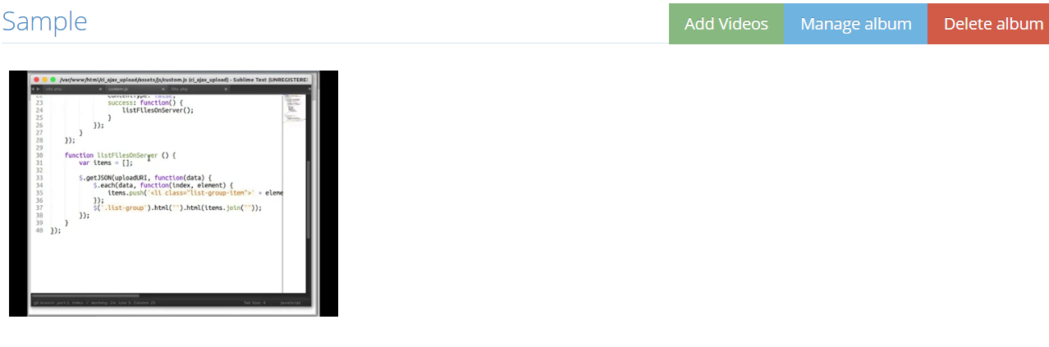

Click the video to play it.

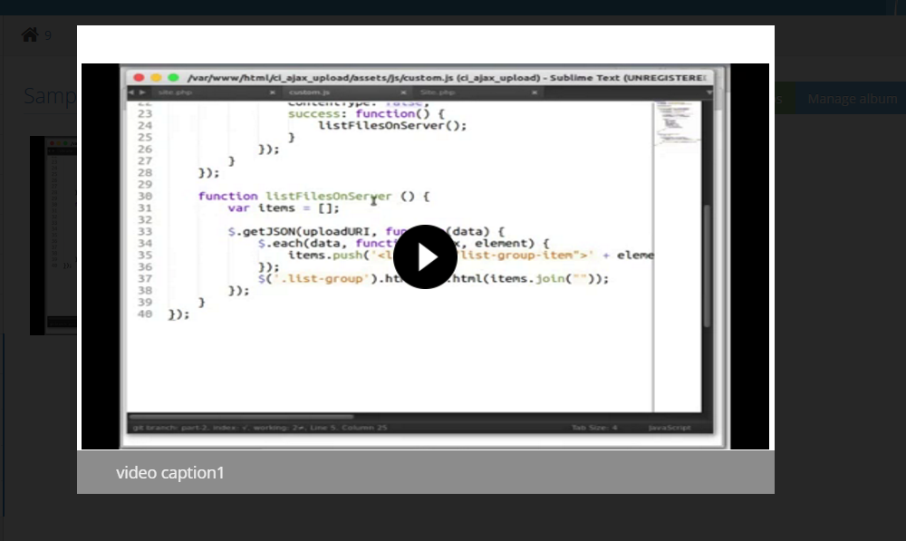

To add more videos in the gallery, click 

Click Manage Files to delete your videos. You can delete only those you have uploaded.

1. **Announcements**

Click the  tab in the side menu. This will redirect you to the Announcements page.

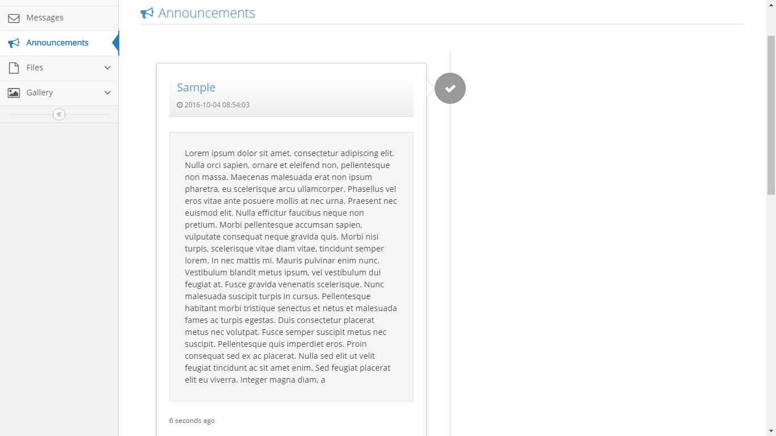

1. **Files**

Click the Files tab found in the side menu then click Upload files.

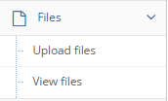

This will then redirect you to the Upload files page.

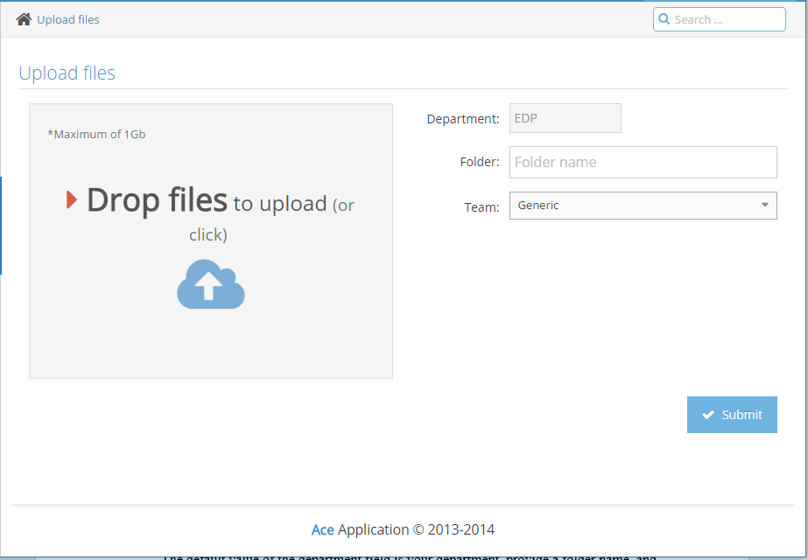

The default value of the department field is your department, provide a folder name, then choose a team if it should only be accessed by a specific team, otherwise, leave it generic.. Click the dropzone area, choose files you want to upload then click the submit button.

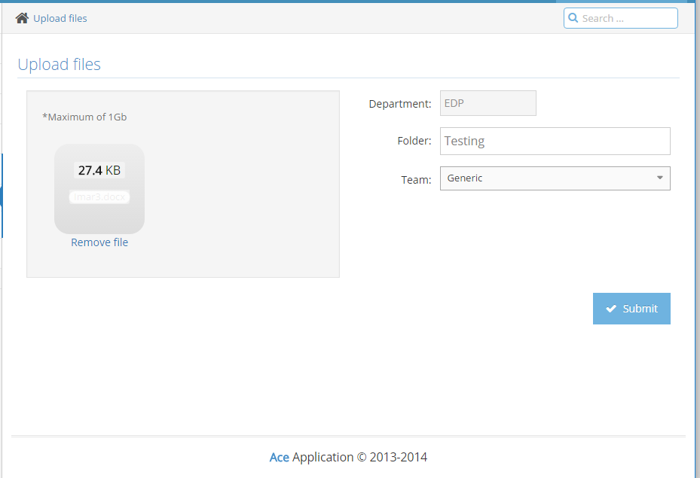

You will be redirected to a page in which the folders of each department is shown in a table. Any image files and files with .docx,.doc,.ppt,.pdf,.txt,.xls,.xlsx,.rar,.zip,.7z extensions are accepted with the max size of 1Gb each file.

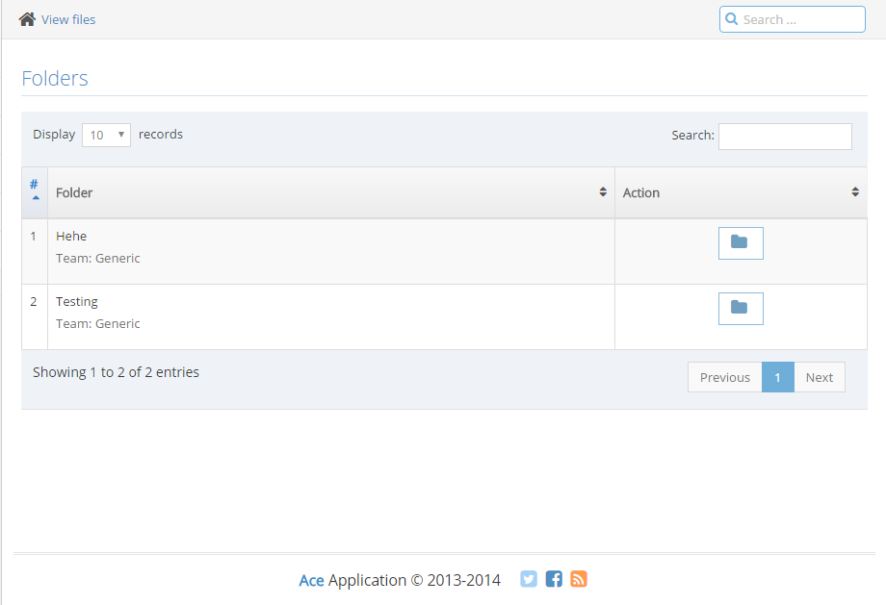

Click the  button at the Action column of the table. This will enable you to view the folders under the department.

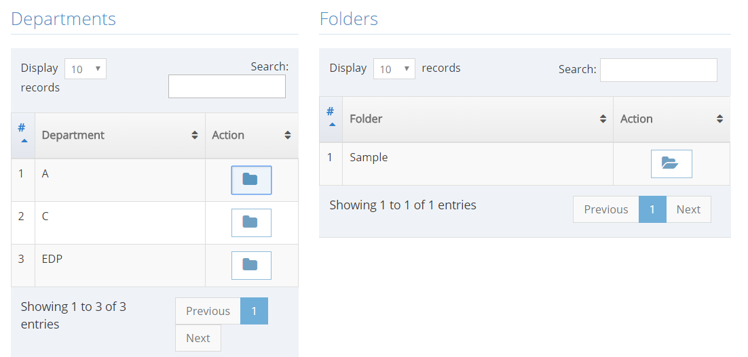

Click the  button found at the Folders table. This enables you to view all of the files uploaded in this folder.

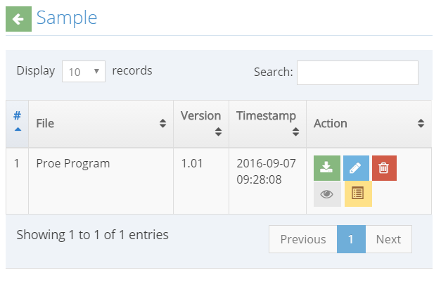

 This button enables you to download the file

 This button deletes the file

 This button lets you view the file. (Not working)

This button triggers a form that enables you to edit the file.

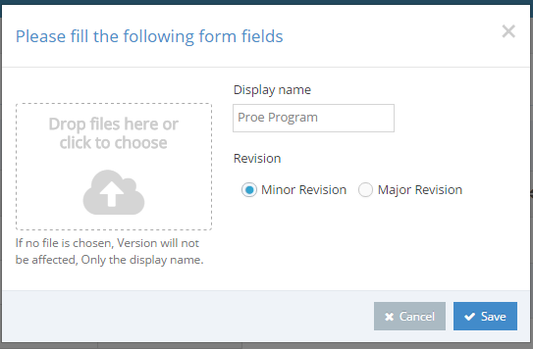

This form lets you upload a new file, input a display name, and choose if the revision made is minor or major.

A minor revision adds a .01 to the current version of your file, while a major revision adds 1 and drops the decimal values.

Ex: File version 1.15 will be file version 2.0 after a major revision.

Click the Save button to save the new version of the file.

You will now see the new version of the file.

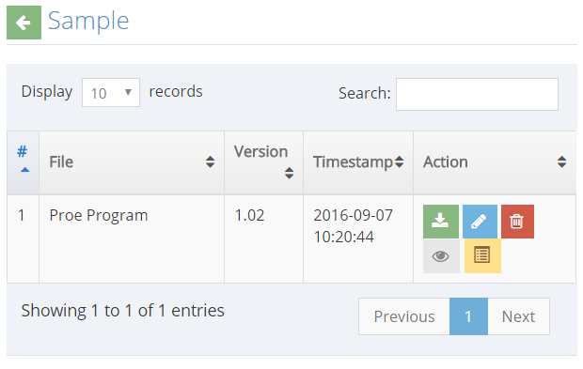

Click the button to view the Archives. This lets you see all of the older versions of the file uploaded in the system.

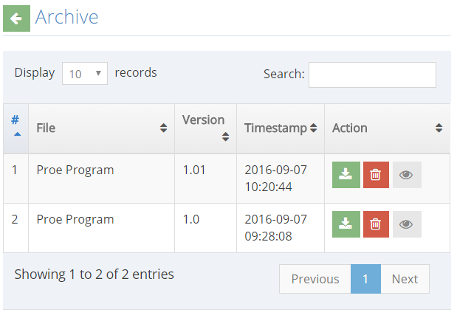

1. **Chat/Messages**

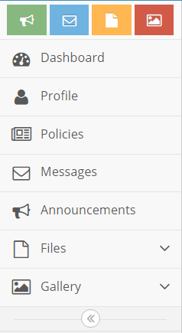

Click the Messages button from the side bar to access the Chat/Messages.

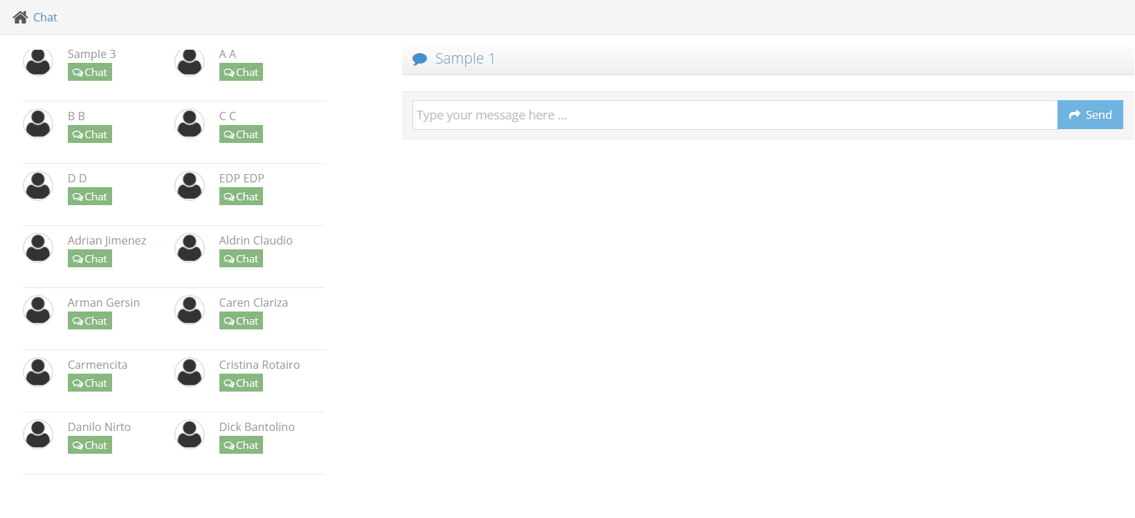

Upon clicking the button, the user/admin will be redirected to the chat page. Click on the “Chat” button below the name of the employee you would like to chat with and type on the right box to engage in a chat.

1. **Logout**

To log out, click  that can be found at the upper right corner of your screen. This will show a dropdown menu. Click the logout button and then you will be redirected to the login page.

